# ­­Lab 2 Regression

Please submit your answers in this word document, including detailed discussion for each question with supportive screenshots of your analysis in SAS EM.

## Linear Regression

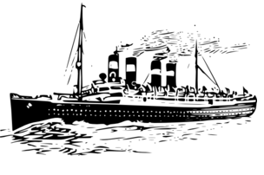Welcome to CastAway Cruise Lines ™!

CastAway Cruise Lines™ is a short to midterm cruise operator based out of the port of Miami. We maintain a fleet of 3 elegant vessels that each have approximately 750 cabins per ship. Each ship has 30 suites (S), 120 Balcony (B) cabins, 150 cabins equipped with a window (W) and 450 Interior (I) cabins. In addition to room type, we track total cost, room costs, shipboard expenses, casino expenses, and excursion expenses for all of our customers. Our primary concern is maintaining our customer satisfaction amongst our patrons. For all of analysis, make sure that Customer Satisfaction Average is ‘Target’ while Overall_1_5_Satisfaction is ‘Rejected’.

As our newest (and only) data analyst you are tasked with the following projects:

1. Is there a relationship between how much a patron’s entire trip costs and their satisfaction? Provide the visual and numerical values that you referenced and justify your conclusion. (Hint: if you choose to use variable clustering node, set Customer satisfaction to ‘Input’ for this question to show it in the correlation matrix. Change it back to target for the other questions.)

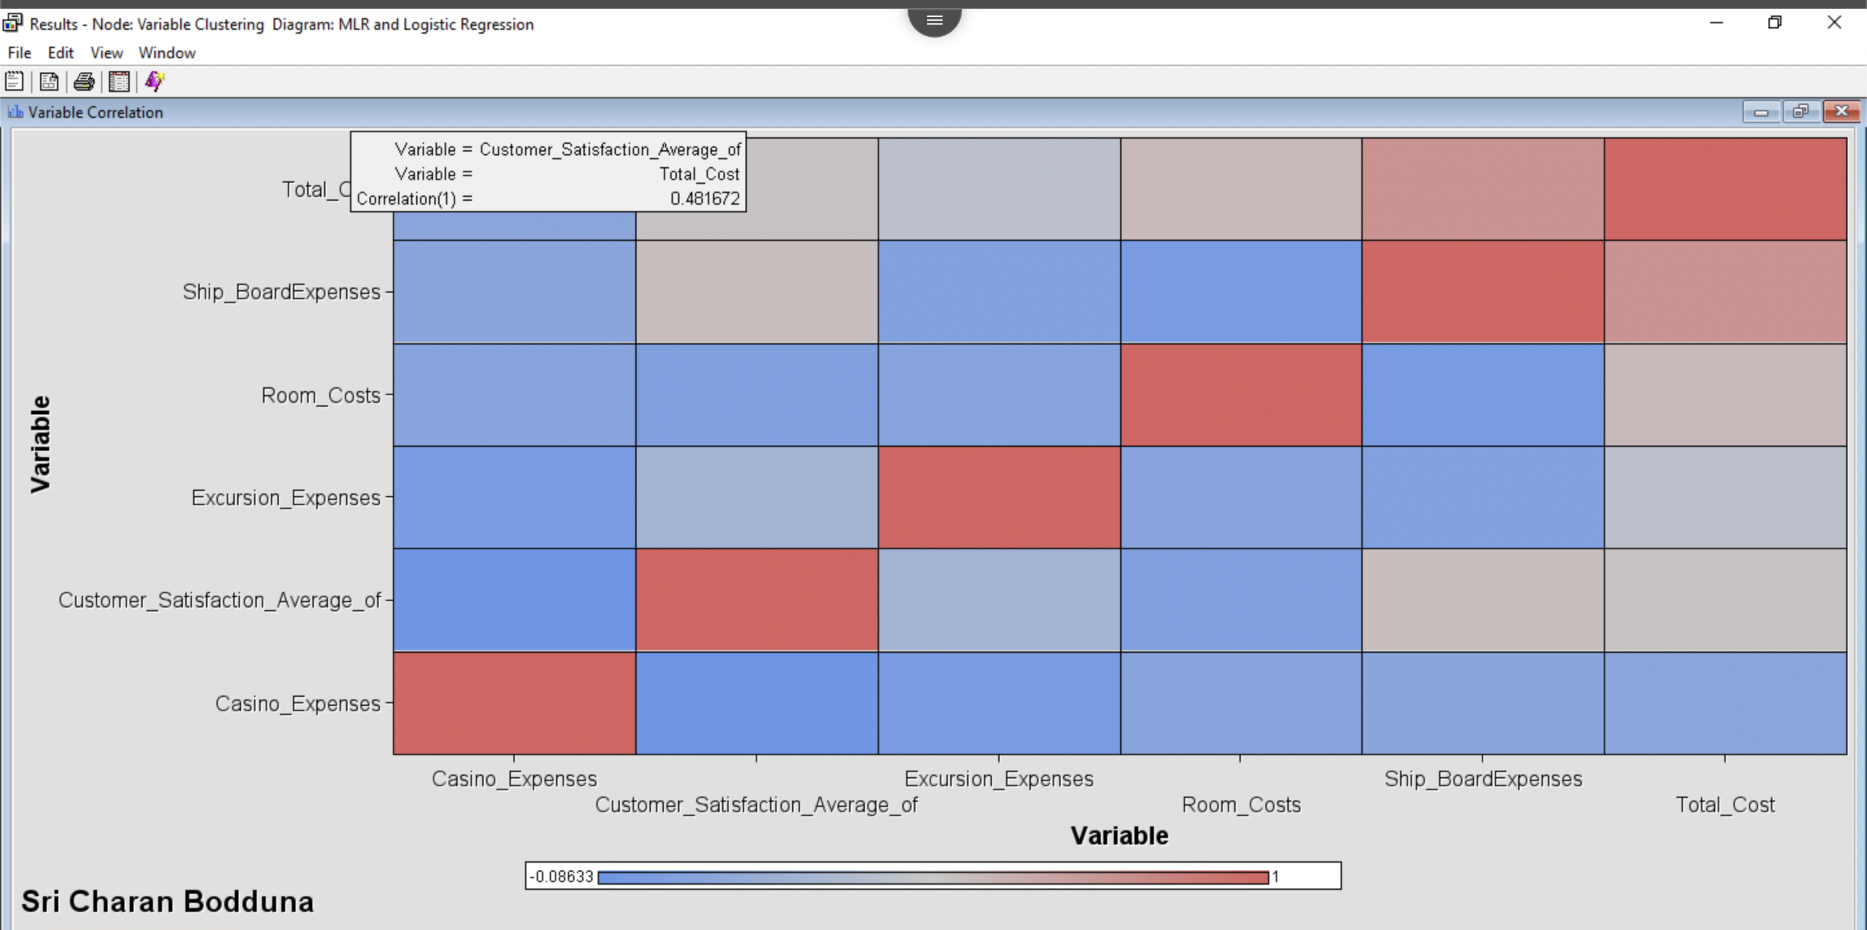

There is the positive correlation relationship between trip cost and average customer satisfaction from the above correlation matrix. We can see correlation coefficient value as 0.48. Which means for unit value increase in the total cost there is an increase in customer satisfaction. The customer satisfaction is high who pays higher total costs.

1. Build the best possible model you could, without any categorical variables, to predict customer satisfaction (Make sure the role of Customer Satisfaction is Target). Show the screenshot of the output of the parameter estimates and significance. How predictive this model is this? Is there any potential for multicollinearity? How did you determine these attributes?

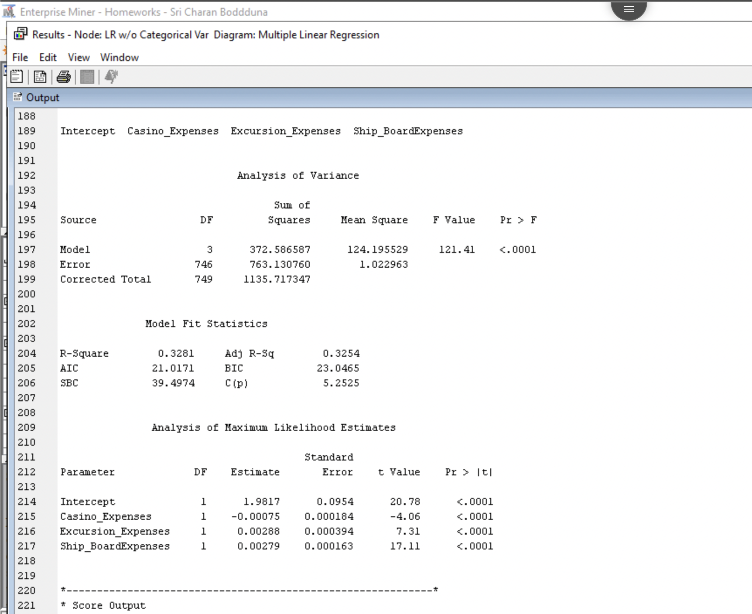

After analyzing the model with various hyper parameters, the best model achieved for the given dataset containing non-categorical values results have shown in the above screenshot. We can see that R2 Square value as 32.81% with adjusted R square value as 32.54%. we can see P value (Pr>F) value as <.0001 which far less than 0.05 significant value. Which means above developed model is correct. We can see model have reduced number of predictors to Excursion Expense, Casino Expense, and Ship Board Expense.

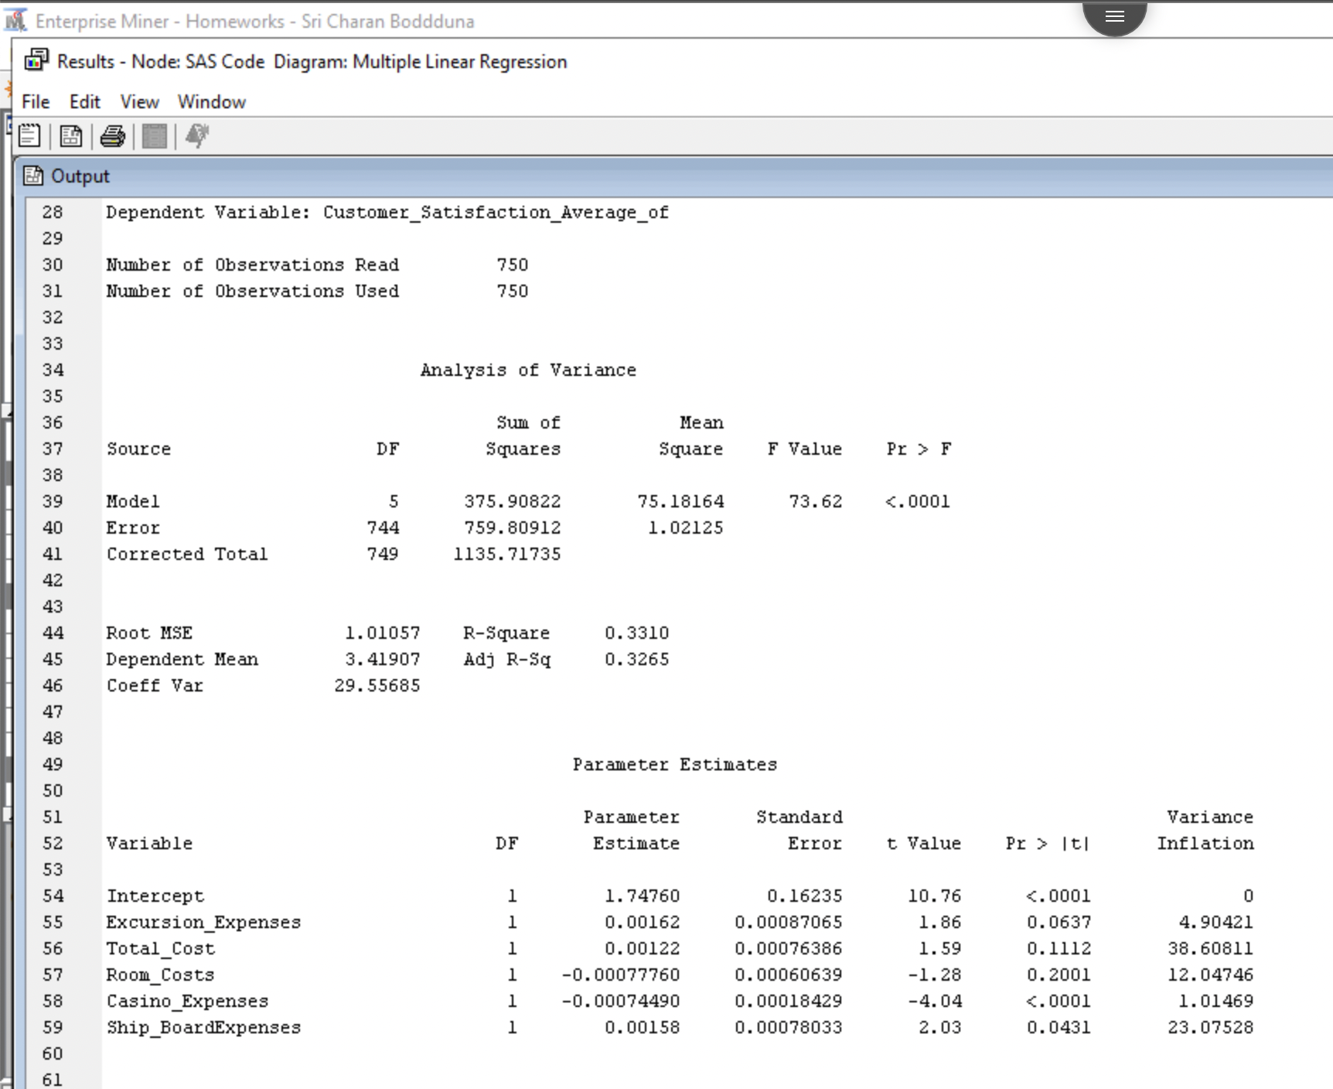

We can also see variance inflation (VIF) for each column in the model. VIF is above 10 for Total_Cost, Room_Costs and Ship_BoardExpenses that means there is a potential for multicollinearity problem.

1. Does the choice of the type of room have significant impact on the customer satisfaction if it is the only predictor? If so which room type(s) is different from the reference type (cabins with a window)? How did you come to this conclusion using the software output?

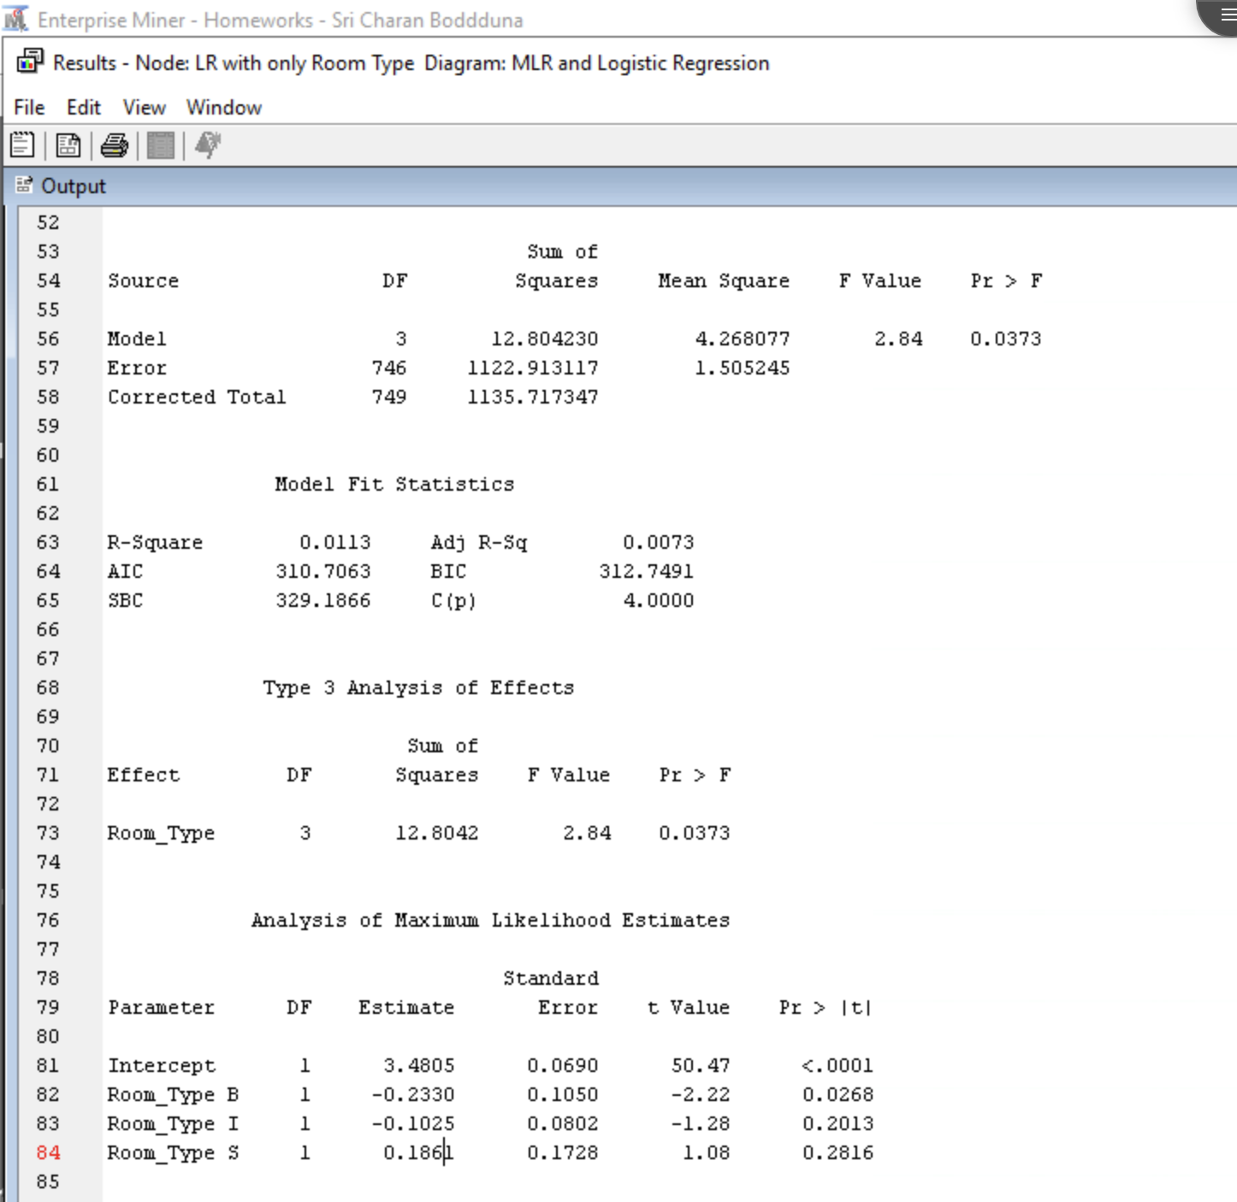

Yes, the model has significant impact on average customer satisfaction with room type. We can conclude it by looking at p value is less than significant value. We can see that only 1% of average customer satisfaction is explained by room type.

We can see that P value of Room Type B has 0.02 which is less than significant value. So Room type B differs from reference type of room type (cabins with window).

1. Considering all predictor candidates including the categorical variable(s), create the best model you can and show the screenshot of the output of the parameter estimates and significance. Also, without real implementations, please discuss a general idea of how to improve this model by creating or adding other categorical variables.

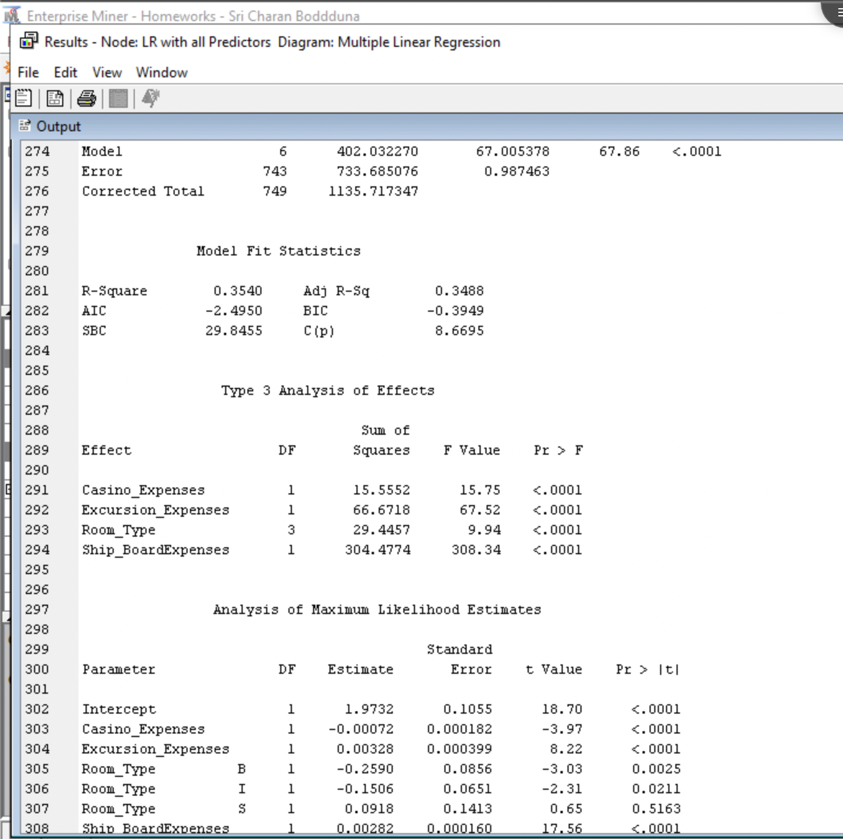

After performing stepwise regression analysis to find out best model with all predictors. I got the R2 value is 35.4%. The screenshot shows the results of the best model shown, which we can conclude from P value of <.0001 is less than significant value. We can also see significant predictors are Casino_Expenses, Excursion_Expenses, Room_Type and Ship_BoardExpenses in predicting average customer satisfaction.

However, the R2 score is less than 0.80 to be a better predictive model. There data does not sufficient to have the better model. We may need to have more features about ships and cruise lines like types of destinations, whether swimming pool present in the ship etc.

1. How can you use this model to increase customer satisfaction? Give specific examples and tie it back to the individual coefficients.

From the best model we found above, we can see that most significant variables are Casino_Expenses, Excursion_Expenses, Room_Type and Ship_BoardExpenses. We can further improve the model based on analyzing interactions between the variables. For example, we can combine Room Type I and Room Type S since the P value of these types have greater value hence, we can reduce it by performing interactions.

## Instructions - Import Data and Edit Variables

1. Download the CastAway_Cruiselines_Data.xlsx file and save it to your computer.
2. Create a diagram titled “Linear Regression Homework”
3. On the “Sample” tab, select the third icon, which is for the File Import Node. Click and drag the File Import Node into your diagram

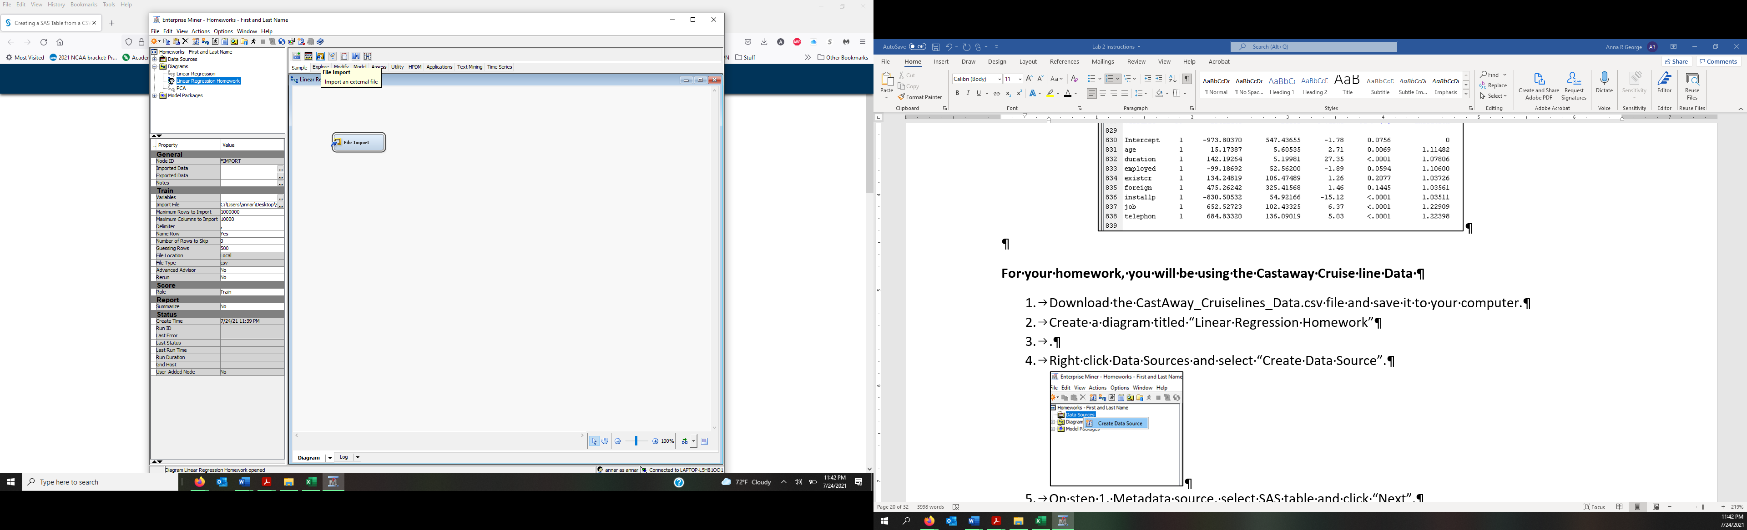

1. Select the File Import Node and under the Train heading, click the Import File ellipses. 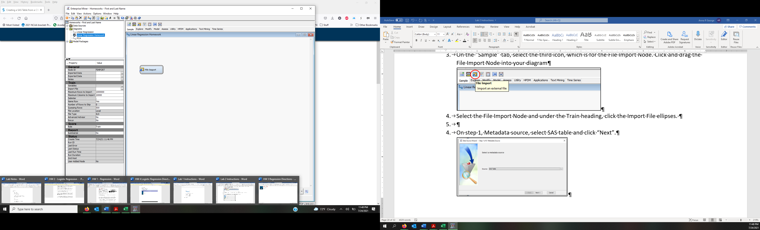
2. In the File Import window, check that “My Computer” is selected and then click “Browse”. Find where you saved the file and select “OK”. (In rare cases that you cannot locate the data file, try saving the data file to a different folder in your local computer and importing from there.)

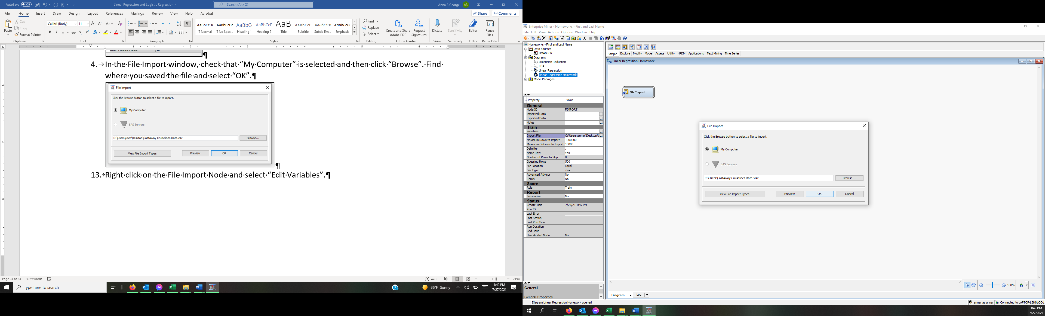

1. Right click on the File Import Node and select “Edit Variables”.

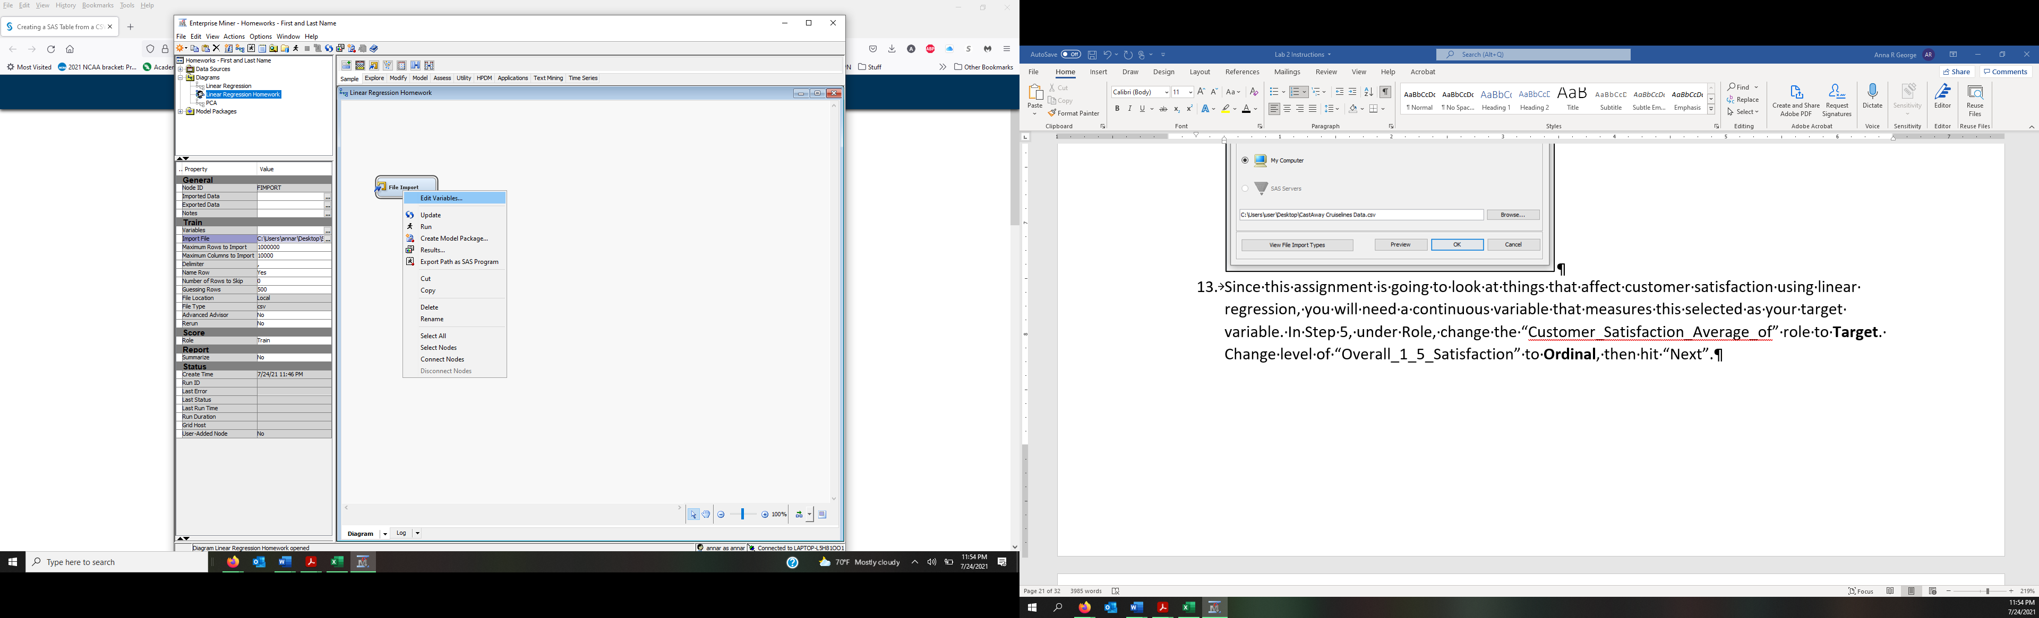

1. Since this assignment is going to look at things that affect customer satisfaction using linear regression, you will need a continuous variable that measures this selected as your target variable. Under Role, change the “Customer_Satisfaction_Average_of” role to **Target**. Change level of “Overall_1_5_Satisfaction” to **Ordinal** and Role to **Rejected**, then click “OK”.

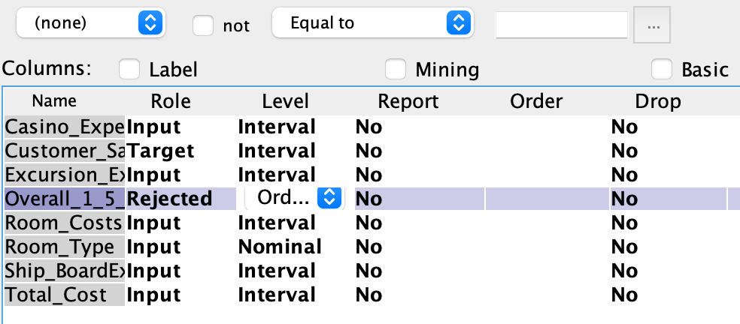

1. Right Click on the Import Node and rename it “CruiseData”.

## Logistic Regression

1. Please provide a screen shot of your Logistic Regression Diagram that includes both the DMAGECR data source analysis in the lab handouts as well as lab assignment using the revised DMAGECR data source. Make sure that the project name (which includes your name) is visible. It will be easier to answer this question in the end of lab when you complete homework analysis in this logistic regression diagram.

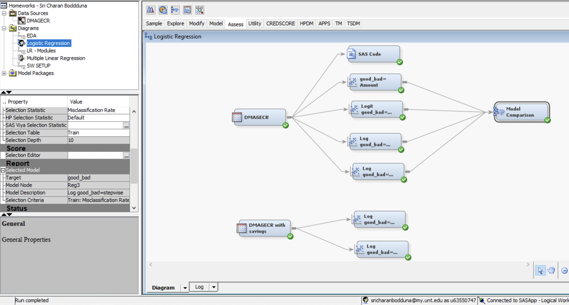

1. Copy and paste the DMAGECR data source and rename it to “DMAGECR w Savings”. Edit the variables in this new data source by changing savings to be an input variable with nominal characteristics. Then copy both Stepwise nodes from the analysis diagram in the lab handouts and connect then to the new data source. The HW analysis you are conducting should look like the screenshot below.

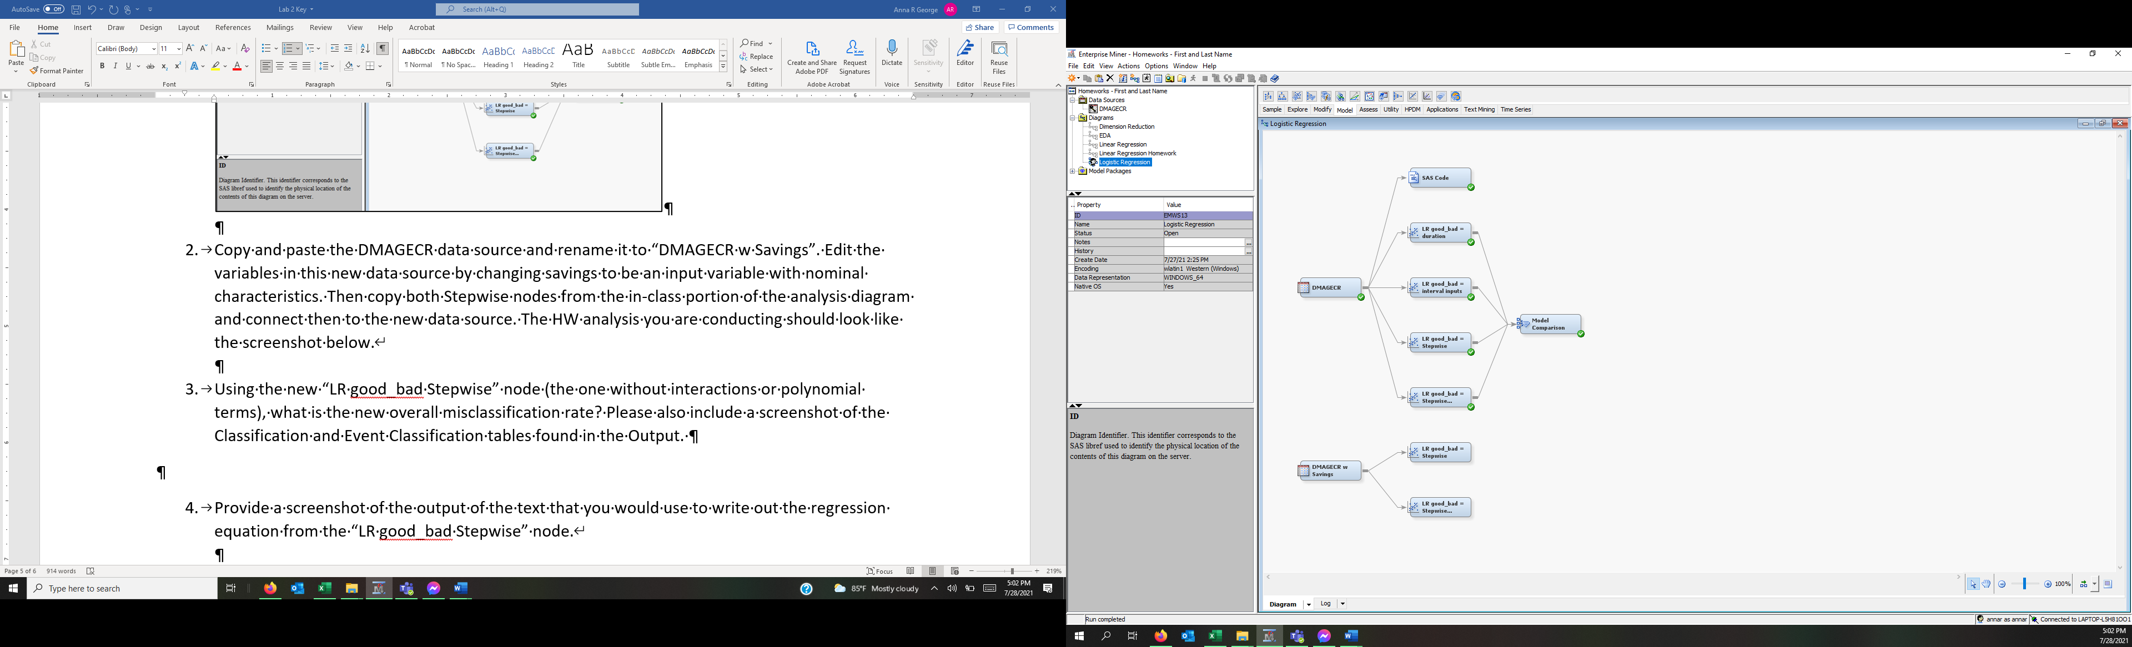

Using the new “LR good_bad = Stepwise” node (the one without interactions or polynomial terms), what is the new overall misclassification rate? Please also include a screenshot of the Classification and Event Classification tables found in the Output.

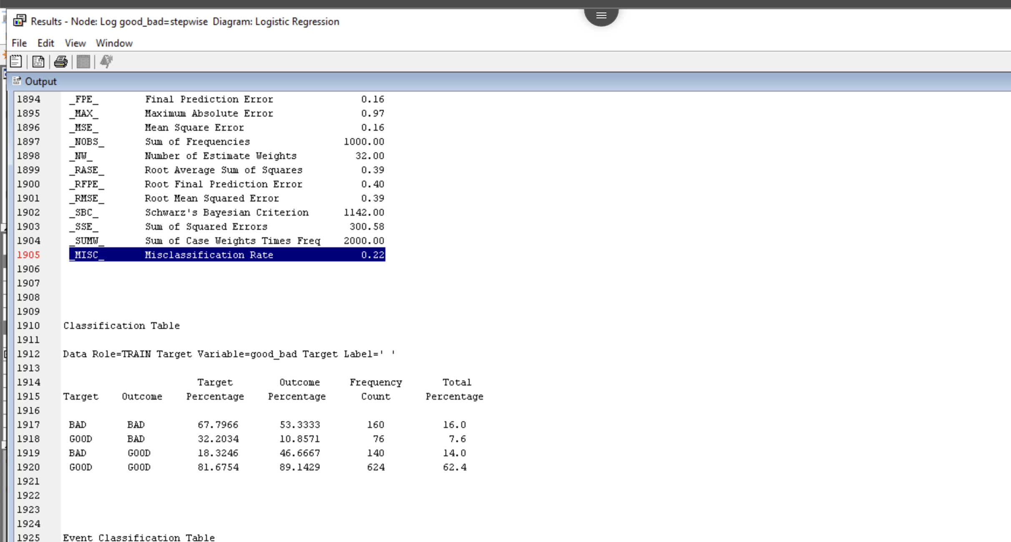

The misclassification rate is 0.22 for the stepwise model.

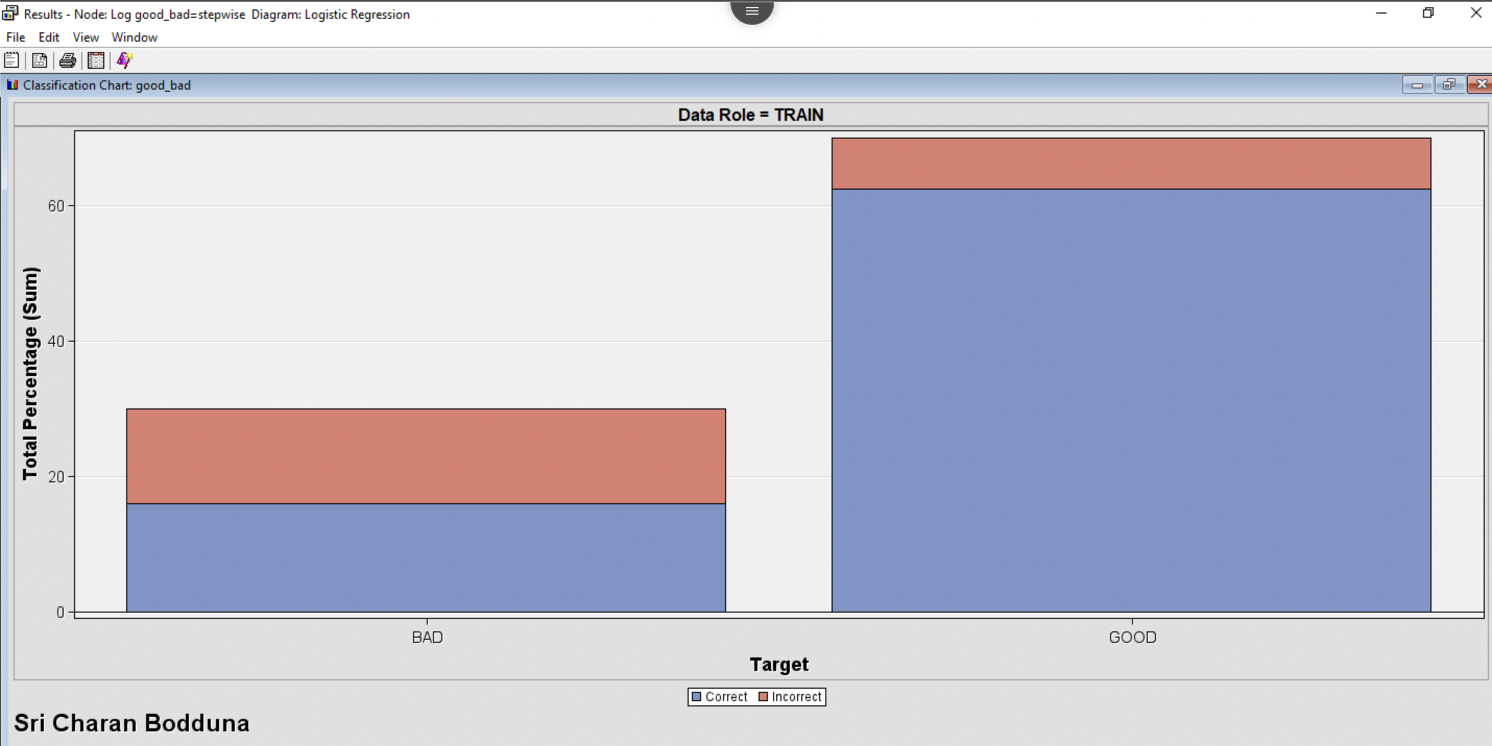

1. Provide a screenshot of the output that you would use to write out the regression equation from the “LR good_bad=Stepwise” node.

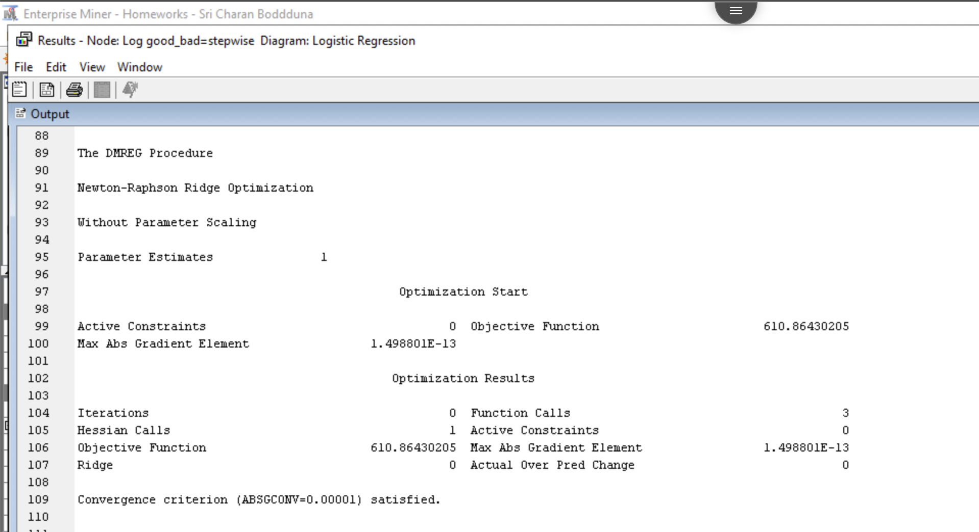

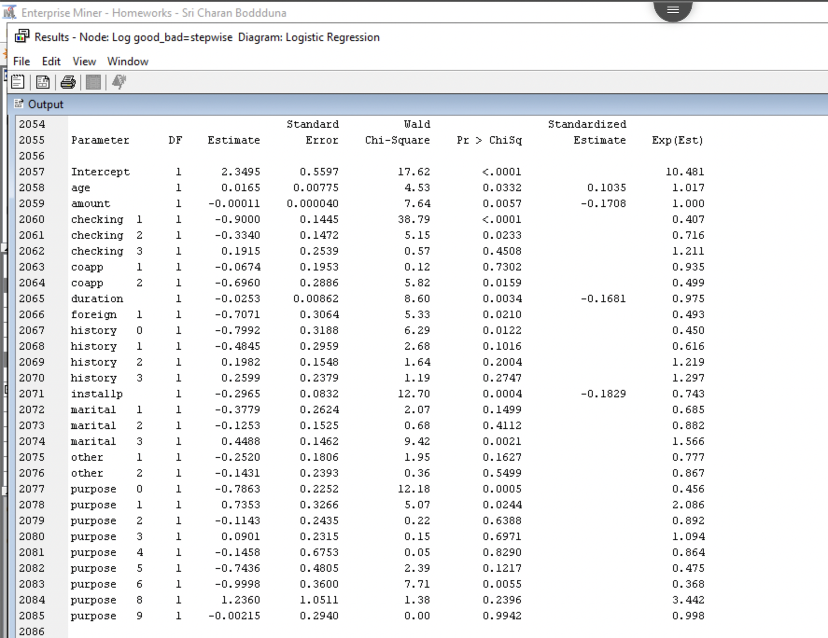

1. Using the new “LR good_bad = Stepwise Interactions and Polynomial” node, what is the new overall misclassification rate? Please include a screenshot of Classification Chart generated under the Assessment tab, Classification and Event Classification tables found in the Output, and the Iteration Plot of the Misclassification Rate under the Model tab. Both are in the View menu of the Results window. Make sure that both images have your first and last name in the footer.

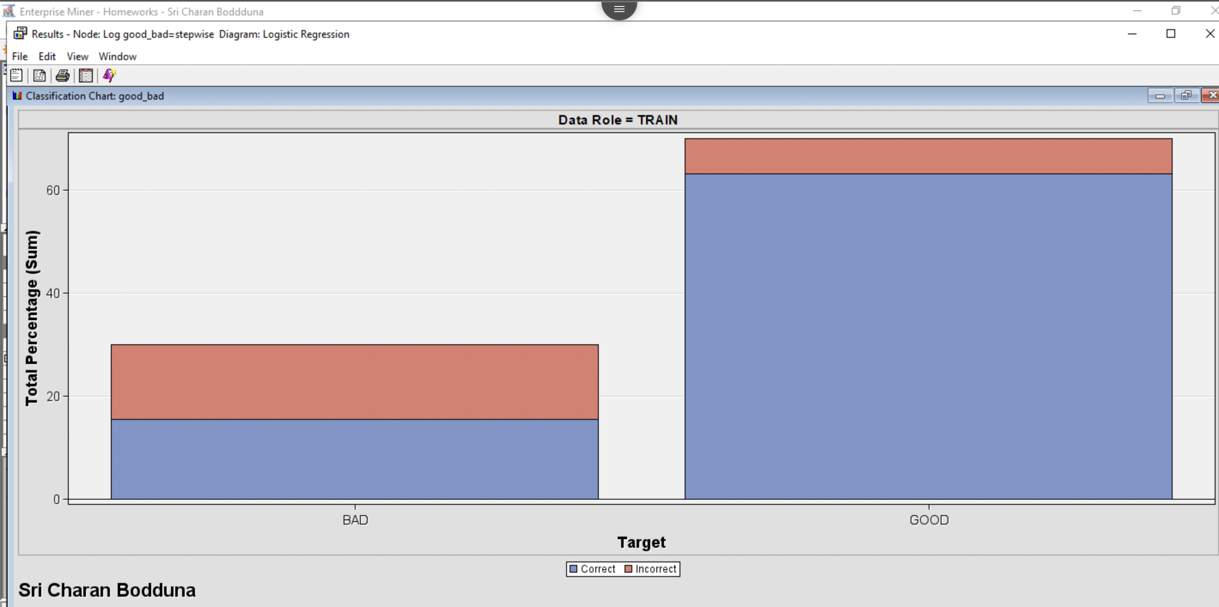

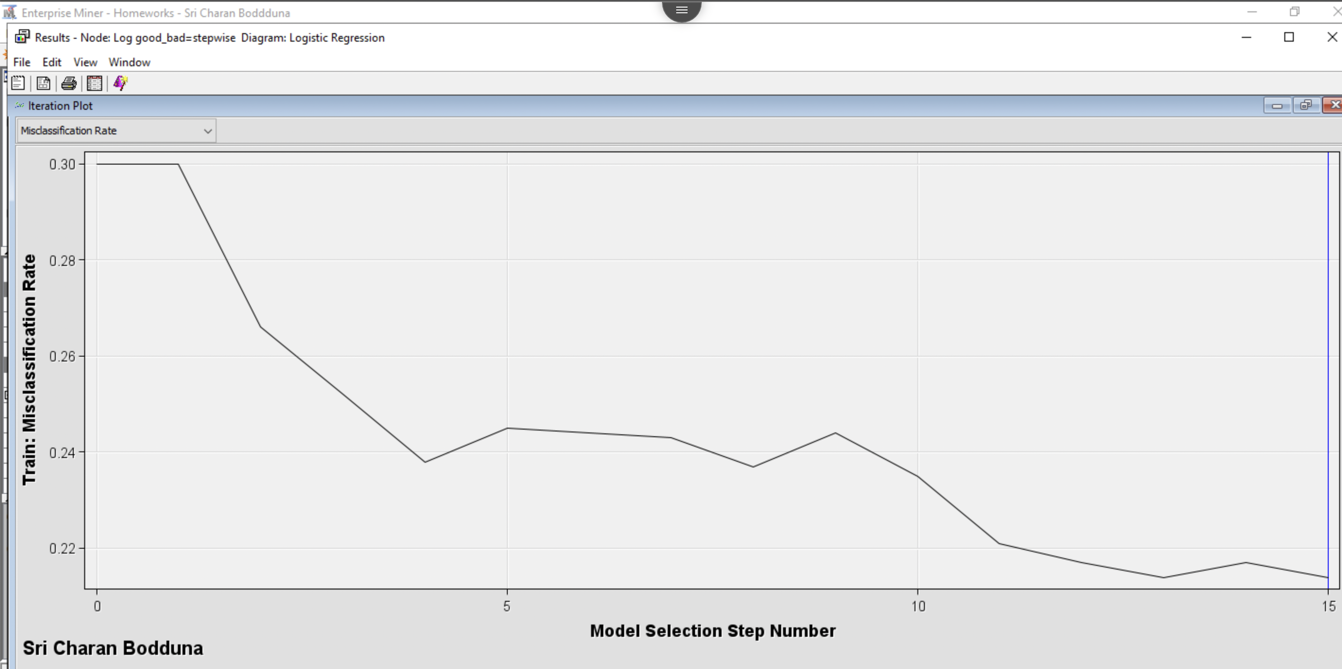

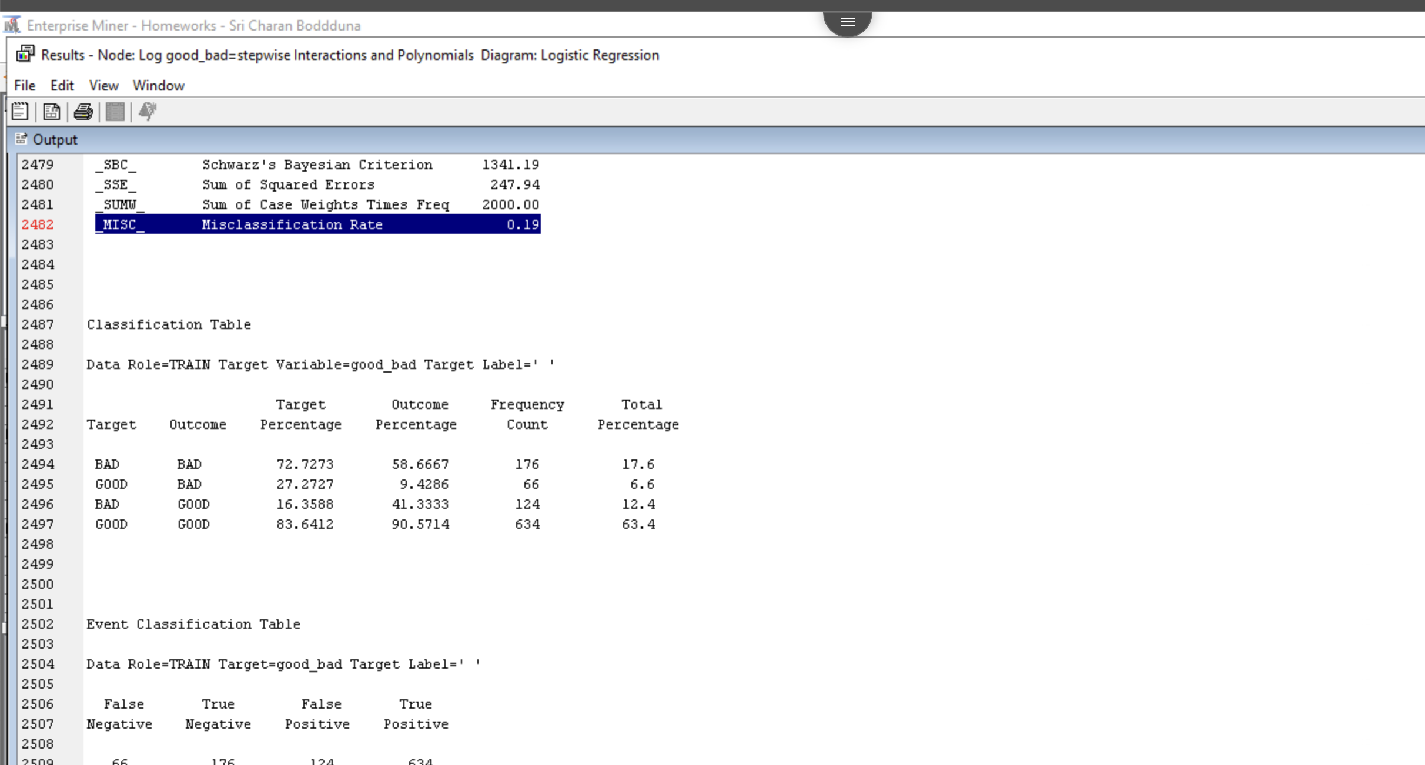

I have taken results from logistic regression stepwise interactions and polynomials model with savings column in the dataset.

The misclassification rate for the logistic regression stepwise interactions and polynomials model is 0.19 with true positive value count is 634 and False Positive count is 124. We can also see that we achieved misclassification rate at 15th iteration.

1. If each new “Good” customer has a net present value (NPV) of $317 and each “Bad” customer has a NPV of -$1,263,
   1. what is the expected profit of offering a loan to all 1,000 customers?

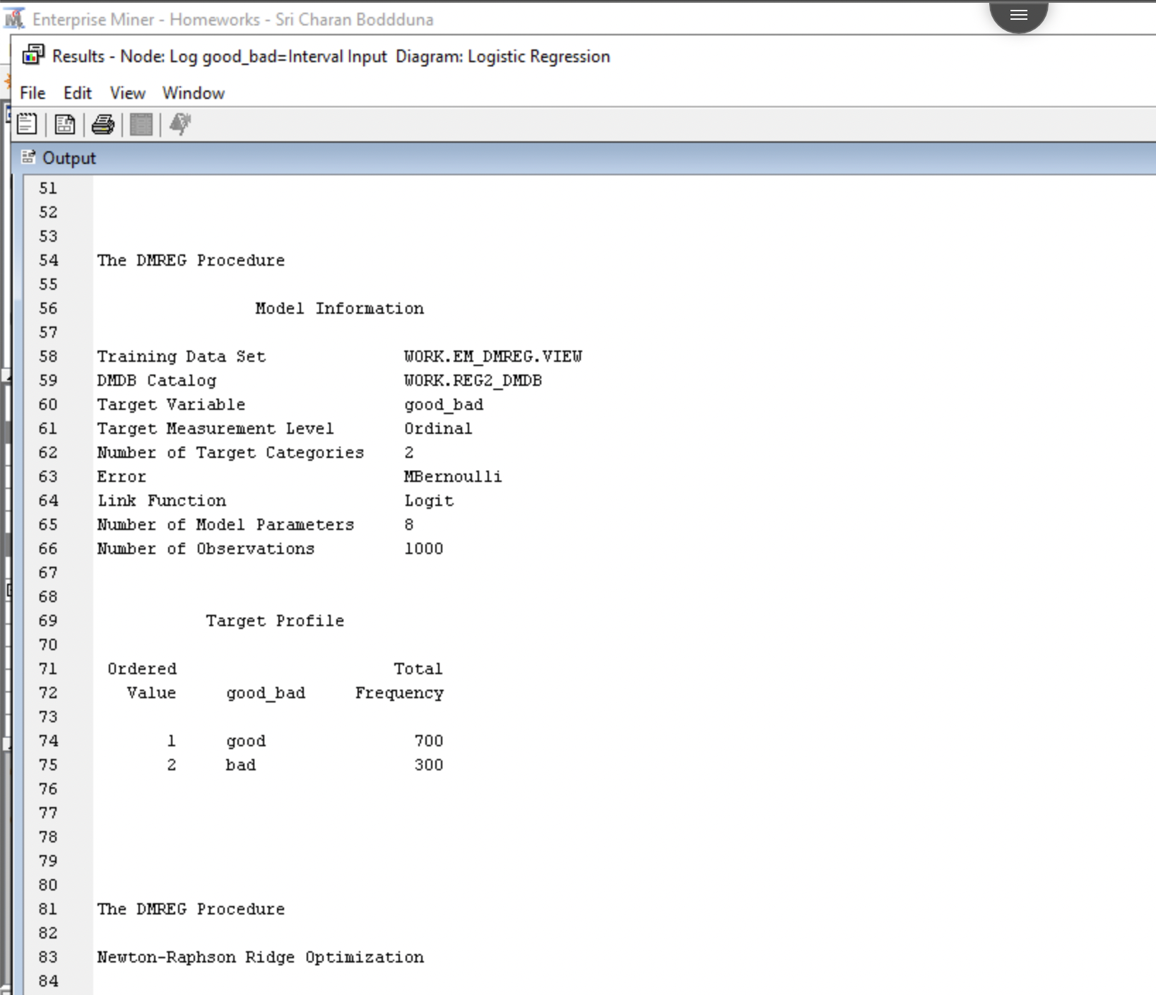

Total number of customers = 1000

Good= 700

Bad = 300

700 * 317 + 300 * (-1263) = **$ -157000.00**

* 1. what is the expected profit of offering a loan to only those classified as “Good” for the LR good_bad=Stepwise model?

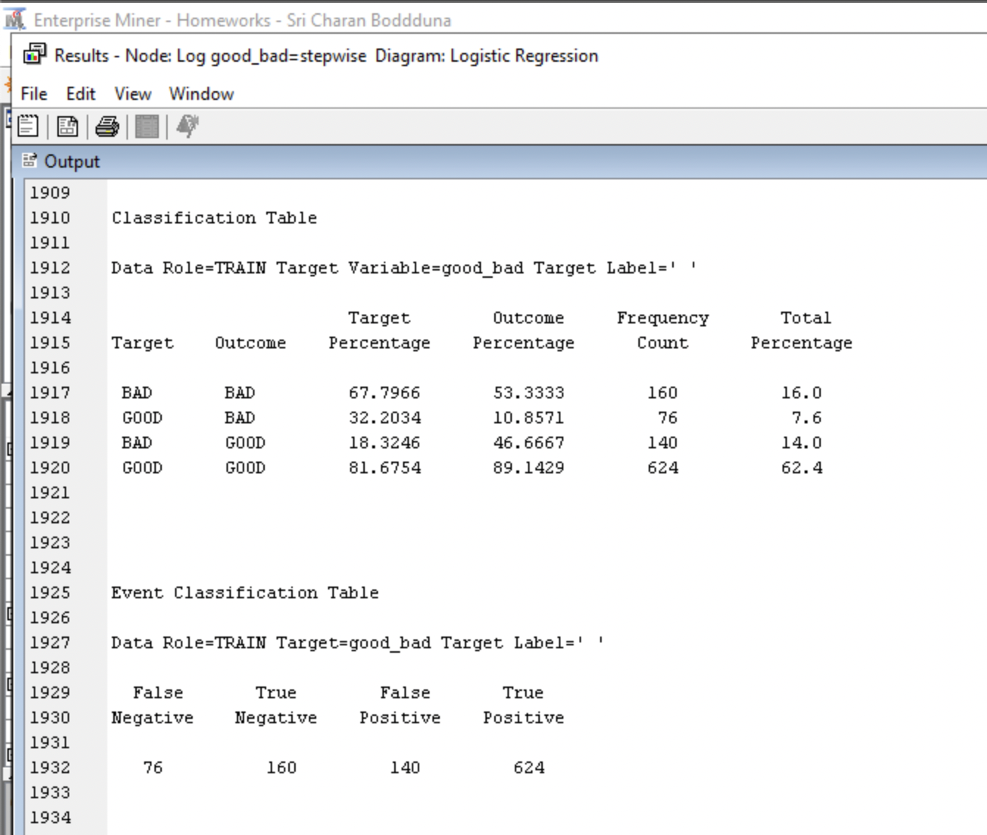

(True positive * 317) + (False Positive * (-1267)

(624 * 317) + (140 * (-1263)) = **$ 20988.00**

* 1. what is the expected profit of offering a loan to only those classified as “Good” for the LR good_bad = Stepwise Interactions and Polynomial model?

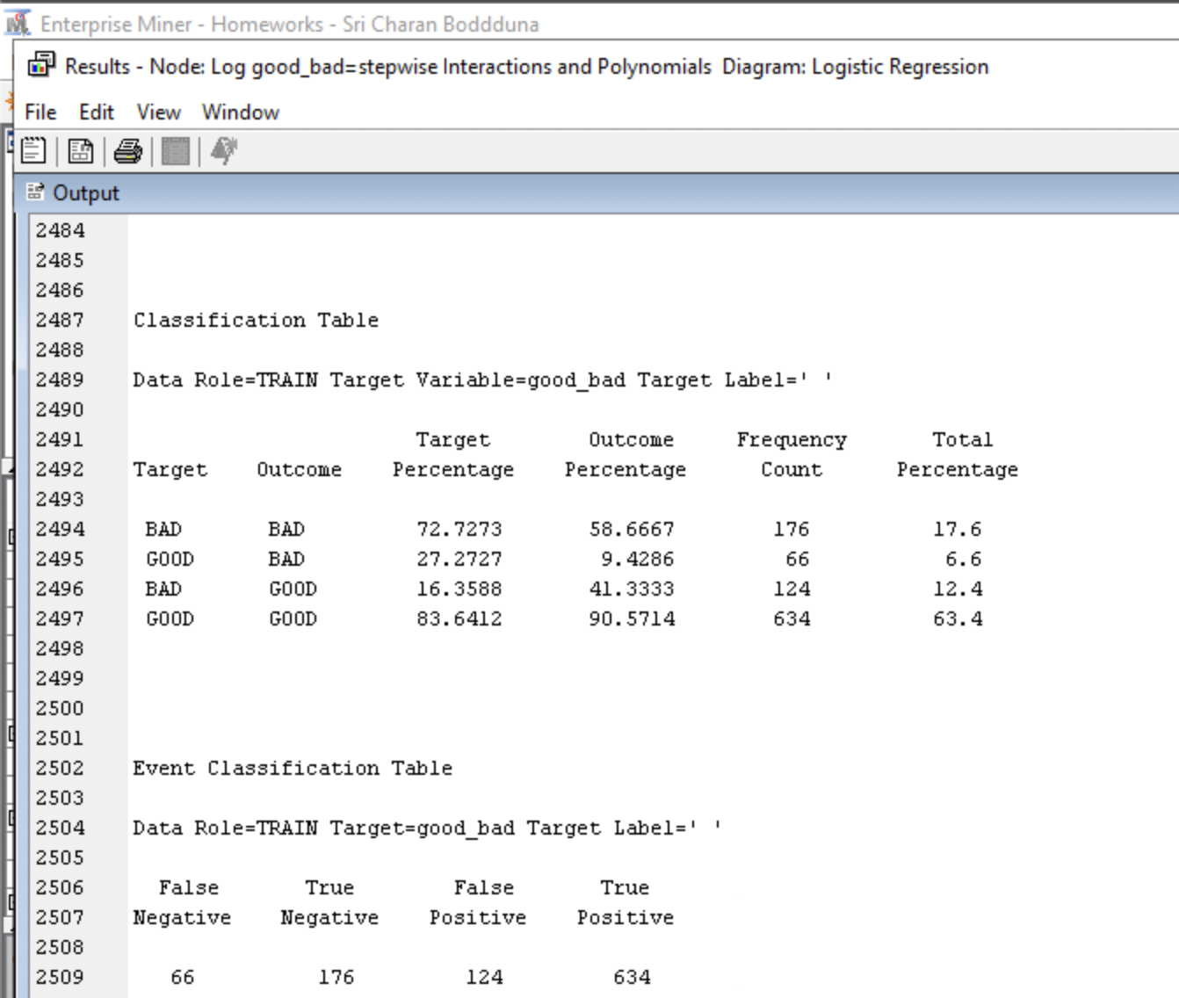

(True positive * 317) + (False Positive * (-1267)

(634 * 317) + (124 * (-1263)) = **$ 44366.00**

* 1. Perform a model comparison based on misclassification rate. Does the model comparison node identify the same model that resulted in the most positive NPV? Provide fit statistics from the output from the model comparison.

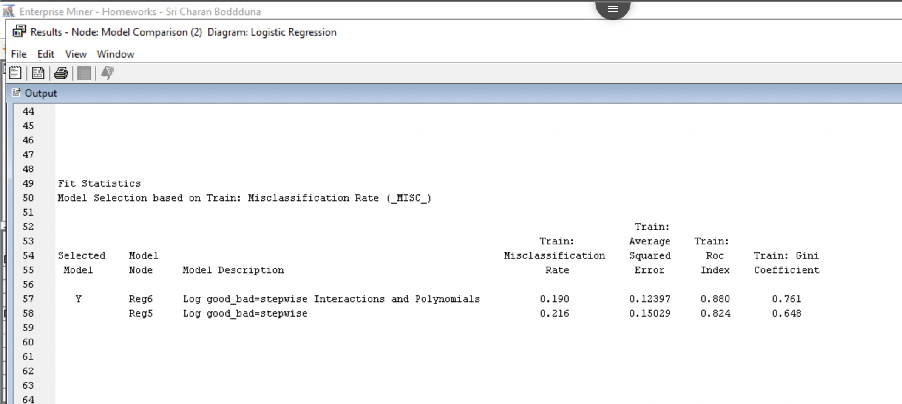

I used model comparison to compare all logistic regression models. From the screenshot above, we can see that least misclassification rate found is for stepwise logistic regression at 0.214. followed by logistic regression stepwise interactions and polynomials at 0.221.

From the above results we found that most positive NPV is for logistic regression stepwise interactions and polynomials, but model comparison node shows least misclassification rate. Which means, model comparison node did not show same model that resulted most positive NPV.